5.3 Leadership and Motivation
Another key aspect of the leading function is motivating workers. Effective leaders motivate individuals to increase the level, direction, and persistence of effort expended at work. Motivation may be defined as what starts behaviors, what maintains behaviors, and what stops behaviors. Leaders are interested in inspiring employees to engage in various behaviors. Table 5.4 provides some examples.
Table 5.4 Motivated behaviors at work
Start and maintain | Stop
Punctuality (arrive on time) | Unhealthy habits (smoking, drugs)
Attendance (arrive every day) | Unethical activities
Effort/productivity | Conflicts
Cooperativeness | Politics
Share information | Inattentiveness
To achieve these goals, leaders can take lessons from the many types of theories of motivation. Three categories of motivation theories are content theories, process theories, and goal-setting theories.

Content Theories of Motivation
Content theories explain the specific factors that motivate people, most notably in the area of human needs. They help explain what drives human behavior, because people will act to fulfill unsatisfied needs, especially the ones they feel are the most urgent. Three major content theories of motivation include Maslow's hierarchy of needs, Herzberg's motivation-hygiene theory, and McClelland's acquired needs theory.

Maslow's Hierarchy of Needs
Abraham Maslow's hierarchy of needs (1954) provides an important foundation of leadership thinking. The model shown in Figure 5.3 employs a satisfaction-progression approach. A person will not progress to the next level of needs until the immediate need has been routinely satisfied.
Lower-order needs include physiological needs, safety needs, and social concerns for belongingness and love. Physiological needs on the job include rest breaks, physical comfort, and reasonable work hours. Safety needs include safe working conditions, job security, base compensation, and benefits. Social needs are met by interactions with friendly coworkers, customers, and a supportive supervisor.
The higher order needs include self-esteem and self-actualization concerns. Self-esteem needs include responsibility for an important job, being promoted, and receiving praise and recognition from the leader. Self-actualization results from creative and challenging work, active participation in decision making, and job autonomy. Self-actualization is realized only if an employee performs tasks and work that express his or her inner self—the person the individual wishes to become.
Maslow's hierarchy has been criticized for several reasons. Commentators suggest that the theory does not explain how strongly a need must be satisfied before progression to the next level can occur. Others suggest that this order of needs is far too rigid and that many people experience them in a far different order. For example, some people's social needs for belongingness and love are far more important than self-actualization. Another problem is that Maslow's hierarchy may not be a comprehensive list of needs. Additional needs exist, including the desire or need for power. Finally, the theory has been criticized for being too vague and not truly explaining how someone would seek to fulfill a need.

Figure 5.3 Maslow's hierarchy of needs
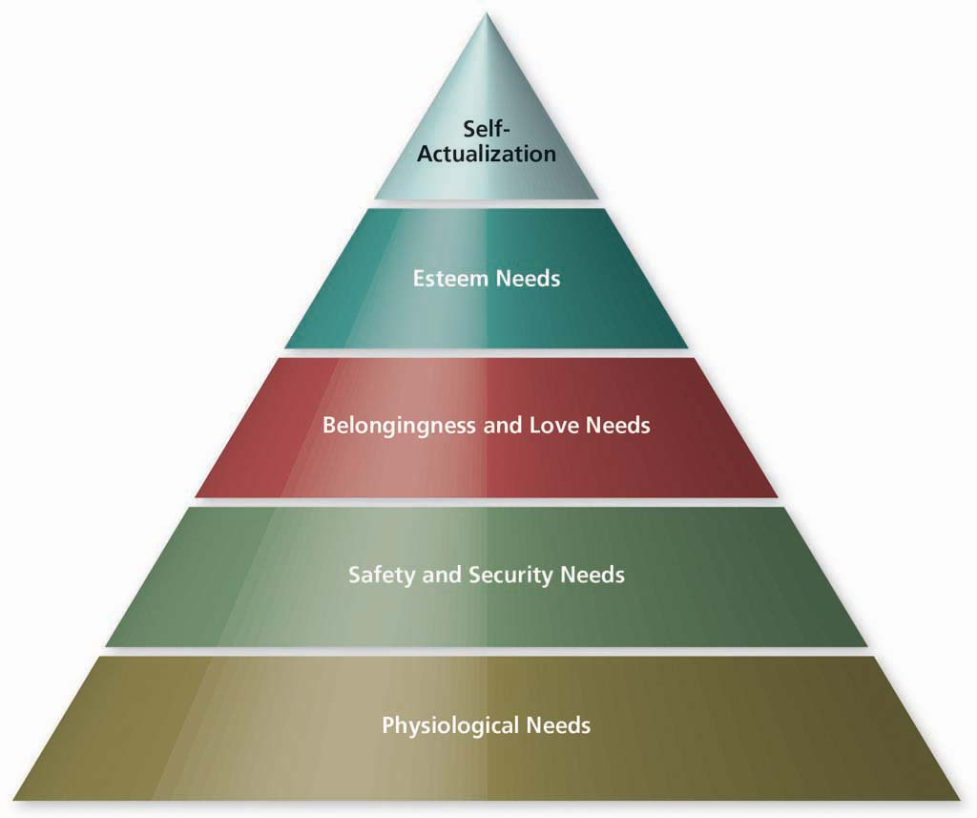
Source: From Abraham Maslow, Robert Frager, James Fadiman, Motivation and Personality, 3rd ed. Copyright © 1987. Reprinted by permission of Pearson Education, Inc., Upper Saddle River, New Jersey.
Despite these criticisms, Maslow's hierarchy built the foundation for other theories of motivation. It stresses the roles that needs play in motivation. It seems clear that, in some way, individuals seek to meet or satisfy needs through various factors that are present in the workplace.

Herzberg's Motivation-Hygiene Theory
Frederick Herzberg's motivation-hygiene theory (1964), also known as the two-factor theory, proposed that work satisfaction and dissatisfaction arise from two different factors. Work satisfaction is associated with motivating factors, and work dissatisfaction comes from hygiene factors. Hygiene factors are those things not directly related to the actual work done, but they play a critical role in either creating or preventing employee dissatisfaction. Table 5.5 presents the hygiene factors and the motivation factors.
Table 5.5 Herzberg's two-factor theory
Hygiene factors (dissatisfiers) | Motivators (satisfiers)
Wages | Achievements
Hours | Recognition
Working conditions | Chance for advancement
Supervisory practices | Responsibility
Rules and procedures | Meaningful work
The factors leading to job satisfaction are separate and distinct from those leading to job dissatisfaction. Leaders who eliminate factors that create job dissatisfaction may bring about peace but not necessarily motivation. They may be attempting to appease rather than motivate the work force. When these factors are satisfactory, employees will not be dissatisfied; neither will they be satisfied. The term hygiene was chosen with a hospital in mind. A clean and germ-free hospital does not necessarily make you well; however, an unsanitary hospital can make you sick. The best leaders can hope for with the hygiene factors is to keep them neutral. In other words, a company that offers fair wages and has a reasonable vacation policy likely will not contribute to an employee's dissatisfaction, whereas the absence of these factors is likely to cause employee dissatisfaction.
In contrast, the factors associated with the work itself are those that inspire motivation in workers. Herzberg believed employees find these characteristics intrinsically rewarding. One management program that can help build motivators, job enrichment, is designed to add higher levels of the motivators to jobs. Job enrichment involves increasing the amount of the following characteristics in jobs:
Skill variety | Number of skills used to perform the job
Task identity | Degree to which the work constitutes something "complete and identifiable"
Task significance | Degree of human interaction
Autonomy | Ability to work without supervision
Feedback | Knowledge regarding performance
As you can see, all these factors would contribute to an employee's finding the work more exciting or challenging. Herzberg believed motivation would result from incorporating them into every job possible.
The two-factor motivation-hygiene theory has been criticized for assuming that motivation and satisfaction are the same thing. In reality, it is possible to be either unmotivated and satisfied or motivated and dissatisfied. The theory does not account for those circumstances. Also, the data was collected from a sample group of professional engineers and accountants. Many have speculated that if Herzberg were to ask the same research questions of a different group, such as unskilled or semiskilled blue-collar workers, the answers might have been quite different.
The motivation-hygiene theory does explain many factors that make people unhappy on the job. Leaders and managers can work to eliminate these issues and find other means to motivate employees. Herzberg's recommendation would be to make each job more interesting and challenging, and many management experts agree with such a recommendation.

McClelland's Acquired Needs Theory
David McClelland developed another motivation theory that is also based on individual needs: the acquired needs theory. The need for achievement is the desire to do something better or more efficiently to master complex tasks. The need for power is the desire to control other people, to influence that behavior, or to be responsible for them. The need for affiliation is the desire to establish and maintain positive and supportive relationships with other people. People develop these needs over time through individual life experiences.
For leaders, the implications of these needs are found in three areas. First, high needs for achievement are associated with performance on the job. McClelland believed it was possible to instill greater needs for achievement within workers by using the proper training techniques (Heckhausen& Krug, 1982). Second, people should be placed on jobs that match their levels of need for achievement, power, and affiliation. Someone who has high affiliation needs should work with people. Someone with achievement needs will be more successful in a job that provides consistent feedback. Third, managers can create challenging task assignments and goals in order to build goal commitment. This effort, in turn, leads to higher levels of performance (Kinicki&Kreitner, 2009, p. 147).

Process Theories of Motivation
Process theories of motivation explain how reasoning processes are associated with motivated (and unmotivated) behaviors. People need to see "what is in it for them" and have a sense that fairness is extended to all involved. Two major process theories include Adams's equity theory and Vroom's expectancy theory.

Adams's Equity Theory
The equity theory of motivation was developed by J. Stacy Adams (1963). The premise of the theory is that perceived equity or inequity plays a major role in motivational processes. The theory may be explained in five steps.
Step one. At work, people exchange inputs for outputs. Inputs are the elements workers trade to the organization, such as time, effort, training, and creative ideas. Outputs are what the organization trades to workers in the forms of pay, praise, the chance to be promoted, challenging work, and other items.
Step two. People have a natural tendency to compare themselves to one another. At work, one special comparison will be made with a referent other, who has been singled out.
Step three. The nature of the comparison is between input-output ratios, as follows:
Inputs of employeeOutputs of employee versus Inputs of referent otherOutputs of referent other
Step four. If the comparison of input-output ratio seems in balance, equilibrium, or equity, then behavior will be maintained. In essence, motivation continues when employees believe they are being treated fairly or equitably.
Step five. If the comparison of input-output ratio seems unequal or inequitable, then there will be a strong motivation force to reestablish equilibrium. To restore equilibrium, employee behaviors can be adjusted in various ways, including the following:
- Change work inputs by putting less effort into their jobs.
- Change work outputs by asking for better treatment, a pay raise, or other rewards.
- Attempt to change the work outputs of a referent other, causing the individual to give lesser or greater effort.
- Change the comparison by finding ways to make things seem better.
- Change the situation by transferring from the job or quitting.
Effective leaders anticipate perceived negative inequities whenever rewards such as pay or promotions are allocated. Instead of letting inequities get out of hand, they carefully communicate the reasons for giving out the rewards. For example, think about a situation in which your friend, who manages a local ice cream parlor, invites you to work part-time hours at a rate of $7.50 per hour. The job's responsibilities include waiting on customers, helping to stock items, and cleaning and closing the store at night. Your friend earns $9.00 per hour, but she also takes care of payroll, hiring and firing workers, purchasing advertising for the store, attending community events, and other managerial activities. In that situation, the comparison of inputs to outputs yields a perception of equity, that the difference in pay is fair based on your friend's additional responsibilities. In that situation, you would be content to maintain your level of effort.
Motivating Employees
If, however, you discovered that one of your coworkers, who you consider to be a real slacker, earns $8.00 per hour, then suddenly inequity exists. Your response might be to give less effort, to ask for a raise, to give your coworker a hard time about "doing his fair share," by reconsidering his level of effort and productivity and concluding that the differences aren't that big, or by looking for another job and eventually quitting.
Equity theory explains when behavior is maintained on the job (equity) and when dissatisfaction leads to negative outcomes (when inequity is present). As a manager-leader, your job is to create circumstances in which all employees believe they are being treated fairly. You probably will pay special attention to your most valuable employees, making sure that their sense of equity is satisfied. After all, they are the people you are most interested in keeping.
Critics point out that people often make unreasonable comparisons. Suppose that someone in your store is comparing his rate of pay to a friend's salary in a union shop, where wages are much higher. The comparison is not reasonable, yet the person becomes dissatisfied because he believes that things are inequitable. Managers can do little to resolve these sorts of conclusions based on false assumptions.
Also notice that part of the theory says a person may change his or her comparison points. In other words, the individual might reappraise the situation and reach an entirely different conclusion. This process may lead a person to perceive inequity for a time and then change his or her mind and decide that things are equitable after all. Once again, this behavior creates complications for managers seeking to motivate employees.

Vroom's Expectancy Theory
Victor Vroom (1964) introduced the expectancy theory of motivation, which asks the question: What determines the willingness of an individual to work hard on tasks important to the organization? Vroom posited that people will do what they can do when they want to do it. Three expectancy factors affect motivation:
- Expectancy (E). An employee's belief that working hard will result in a desired level of task performance being achieved.
- Instrumentality (I). An employee's belief that successful performance will be followed by rewards and other desirable outcomes.
- Valence (V). The value an employee assigns to the possible rewards and other work-related outcomes.
Vroom suggests that for motivation to be present, expectancy, instrumentality, and valence must all be present at the same time. In other words:
Motivation = E × I × V
If any of the three expectancy factors were missing, zero motivation would be present. The higher the values of E, I, and V, the more powerful the motivational force becomes. Leaders can take advantage of the principles of expectancy theory by understanding worker valences (knowing what employees value); clarifying the work situation (making it seem more likely to the employee that successful performance is possible); and rewarding successful performance with the valences held by employees. Expectancy theory has received a great deal of favorable research results. Leaders enjoy the benefit of an easy-to-apply system of motivation using the theory.

MANAGEMENT IN PRACTICE

Expectancy Theory
As an example of expectancy theory, suppose that a manager in a local food establishment works directly with four employees. The four employees have widely different goals for the job. One only wants to pick up a paycheck, because he attends college as well. A second wants to learn the business, because someday she hopes to open her own restaurant. The third wants to make as much money as possible, because he is helping to support a family. The fourth wants to have fun and make friends because she is still in high school, works for spending money, and has strong social needs.
As a manager, you should notice that each employee expresses different valences. Your role would be to tailor rewards to each person's desired outcome. Then, you should clear the path to those rewards by establishing clear expectations about how to do the job well and by providing consistent feedback, both when employees perform well and when they make a mistake. Then, it would be your responsibility to make sure that those employees who achieve and do their jobs correctly and at high levels receive the rewards they desire. The first simply wants to keep matters as uncomplicated as possible and may wish to have certain nights free to study for exams or prepare term papers. The second craves additional instruction and insight into the restaurant business, which can be delivered with one-on-one coaching sessions. The third can be taught methods for receiving the best tips and other ways to earn extra money, including being assigned to shifts when the restaurant is the busiest. The fourth can be moved into situations where she works with her friends and engages with the public. These four rewards should then result in the best performance possible for all four workers, so long as you carry out the other aspects of the theory.
Further consider the relationship between expectancy theory in this section and the leadership theories discussed in Section 5.2. Many elements of path–goal theory correspond to the ideas put forth in expectancy theory. Both stress the importance of relations between the manager-leader and the followers. Strong, positive relationships lead to increased motivation in the employee and successful outcomes for the leader.
Discussion Questions
- Describe the connections that you observe between expectancy theory and the path–goal theory of leadership.
- Explain how you would connect all three elements of expectancy theory (valences, instrumentality, expectancy) to your efforts in managing each of the four employees described in this section.
- Can you identify any problems or complications that would keep you, as a manager, from using expectancy theory in this situation?

Locke's Goal-Setting Theory
Goals in the form of clear and important performance targets are the basis of Edwin Locke's (1968) goal-setting theory. A goal is the object or aim of an action; it is what an individual is trying to accomplish. The theory is based on the premise that task goals can be highly motivating if they are properly set and well managed. Goal-setting theory includes four concepts:
- Goals direct attention toward relevant activities and away from unnecessary activities.
- Goals regulate effort by focusing on the most important action to be taken.
- Goals increase persistence, leading the worker to stay on task.
- Goals foster the development and application of task strategies and action plans.
Goals clarify performance expectations, establish a frame of reference for feedback, and provide a basis for self-management. In these ways, Locke believed that goal setting can enhance work performance and job satisfaction.
A key component of the theory is that managers and leaders must work with others to set the right goals in the right ways. Goals must be difficult but achievable, specific, measurable, realistic, and timely. It is important for both the leader and follower to participate in setting the desired goals.
A substantial amount of research supports goal-setting theory. One system companies use to establish and support goal setting for all employees is management by objective. This is a participative goal-setting program in which supervisors and employees negotiate goal lists and performance objectives on an annual basis. In general, effective leaders inspire motivation by understanding worker needs and helping employees satisfy those needs by creating a supportive work environment. Leaders know that workers compare themselves to one another. In response, effective leaders strive to make the reward system as fair and equitable as possible. Effective leaders comprehend the relationship between knowing what workers want, showing them how to effectively complete assigned tasks, and rewarding successful employees with the things they want. Goal-setting systems allow leaders to establish meaningful performance targets and reward subsequent performance. A program such as management by objectives can institutionalize the goal-setting process throughout the organization.

Relationships Between Theories
In case you are wondering if it is possible to incorporate all of these ideas into a systematic approach to leading, the answer is yes. Effective managers take concepts from each of these theories and models and apply them to their own situation, organization, and followers.
The primary approaches to leadership include traits and characteristics models, people and production (behavioral and situational) theories, and more recent views including path–goal theory and transformational leadership theory. The common ground for all these theories resides in two basic notions. First, some leaders are especially talented at working with people in various ways, either through displays of traits and characteristics that are people centered, by helping people achieve the best outcomes by clarifying paths for them, or by leading people by setting a transformational example. Second, the leadership theories note the role that work performance plays. Effective leaders display the traits and characteristics that guide people to achieve at higher levels. They clarify paths related to effective performance, and they challenge others to do their best through the transformational skills they exhibit. Perhaps the original Ohio State study authors said it best: Effective leadership has both job-centered and people-centered components.
The motivational theories include those oriented to needs, those that focus on thought processes, and those that focus on goals. Once again, these theories have common bonds. Needs are quite similar to valences in that both express a positive desired outcome experienced by an employee. One such need or valence would be feeling that you are treated fairly. Another would result from the sense of personal satisfaction associated with achieving your goals. In other words, each of the categories of motivation theories focus on doing things that fulfill basic desired outcomes (satisfy a need, achieve a valence, have a sense of being treated fairly, or reach personal goals).
As a result, connections between leadership theories and motivational theories can be readily drawn. An effective, people-centered leader takes the time to understand what his or her workers want. This includes knowing about basic employee needs, fine-tuning a leading style to incorporate individual valences into a reward system, and treating people fairly and equitably. Finally, the good leader knows that only when promises are kept will the people under his or her direction be motivated. There is nothing worse than a leader who holds out a reward for desired performance and then does not deliver the reward when the follower succeeds or achieves a desired outcome. There is nothing better than a consistent leader who always delivers what he or she promises to employees who succeed.
Then, an effective job-centered leader can tie concepts regarding rewards and need fulfillment with methods designed to improve job performance. The leader delivers quality instruction, corrects errors in a positive fashion, seeks employee involvement in improving the work process, sets clear, meaningful, and achievable goals, and takes other steps to make sure each individual can perform at the highest level. Chances are, if you do these things, you will be perceived as having the traits and characteristics of an effective leader

